**CAR SHOWROOM MANAGEMENT SYSTEM**

**ABSTRACT**

This project designs and implements a car showroom management system using SQL. The system stores and manages data about cars, customers, sales and inventory. It also generates reports and queries for decision making. The project follows six phases: design, implementation, user interface development, testing, report generation and documentation. The project uses a relational database model and the waterfall methodology. The project shows how SQL can create and manipulate databases effectively. The project also shows how a car showroom management system can improve showroom efficiency and effectiveness.

* **AIM OF PROJECT**

The aim of this project is to design and implement a car showroom management system using SQL. The system will store and manage information about the cars, customers, sales and inventory of the showroom. The system will also provide various reports and queries to help the showroom staff and managers perform their tasks efficiently and effectively.

* **INTRODUCTION**

Car showrooms are places where customers can buy new or used cars from various brands and models. They also offer services such as car maintenance, repair, insurance and financing. Managing a car showroom requires a lot of information and data, such as the details of the cars, customers, sales and inventory. A car showroom management system is a software application that helps the showroom staff and managers to store and manage this information and data using a database. The system also provides various reports and queries to help them perform their tasks efficiently and effectively. The aim of this project is to design and implement a car showroom management system using SQL. The objectives of this project are to create a relational database schema, implement the database, create various stored procedures, functions, triggers and views, develop a user interface, test the functionality and performance of the system, generate various reports and queries, and document the system design, implementation and testing process. The scope of this project is limited to the car showroom management system only and does not include other aspects such as marketing, customer relationship management or online sales.

* **OBJECTIVE OF PROJECT**
* To design a relational database schema for the car showroom management system using SQL
* To generate various reports and queries to support the decision making of the showroom staff and managers
* To document the system design, implementation and testing process

**ER DIAGRAM**

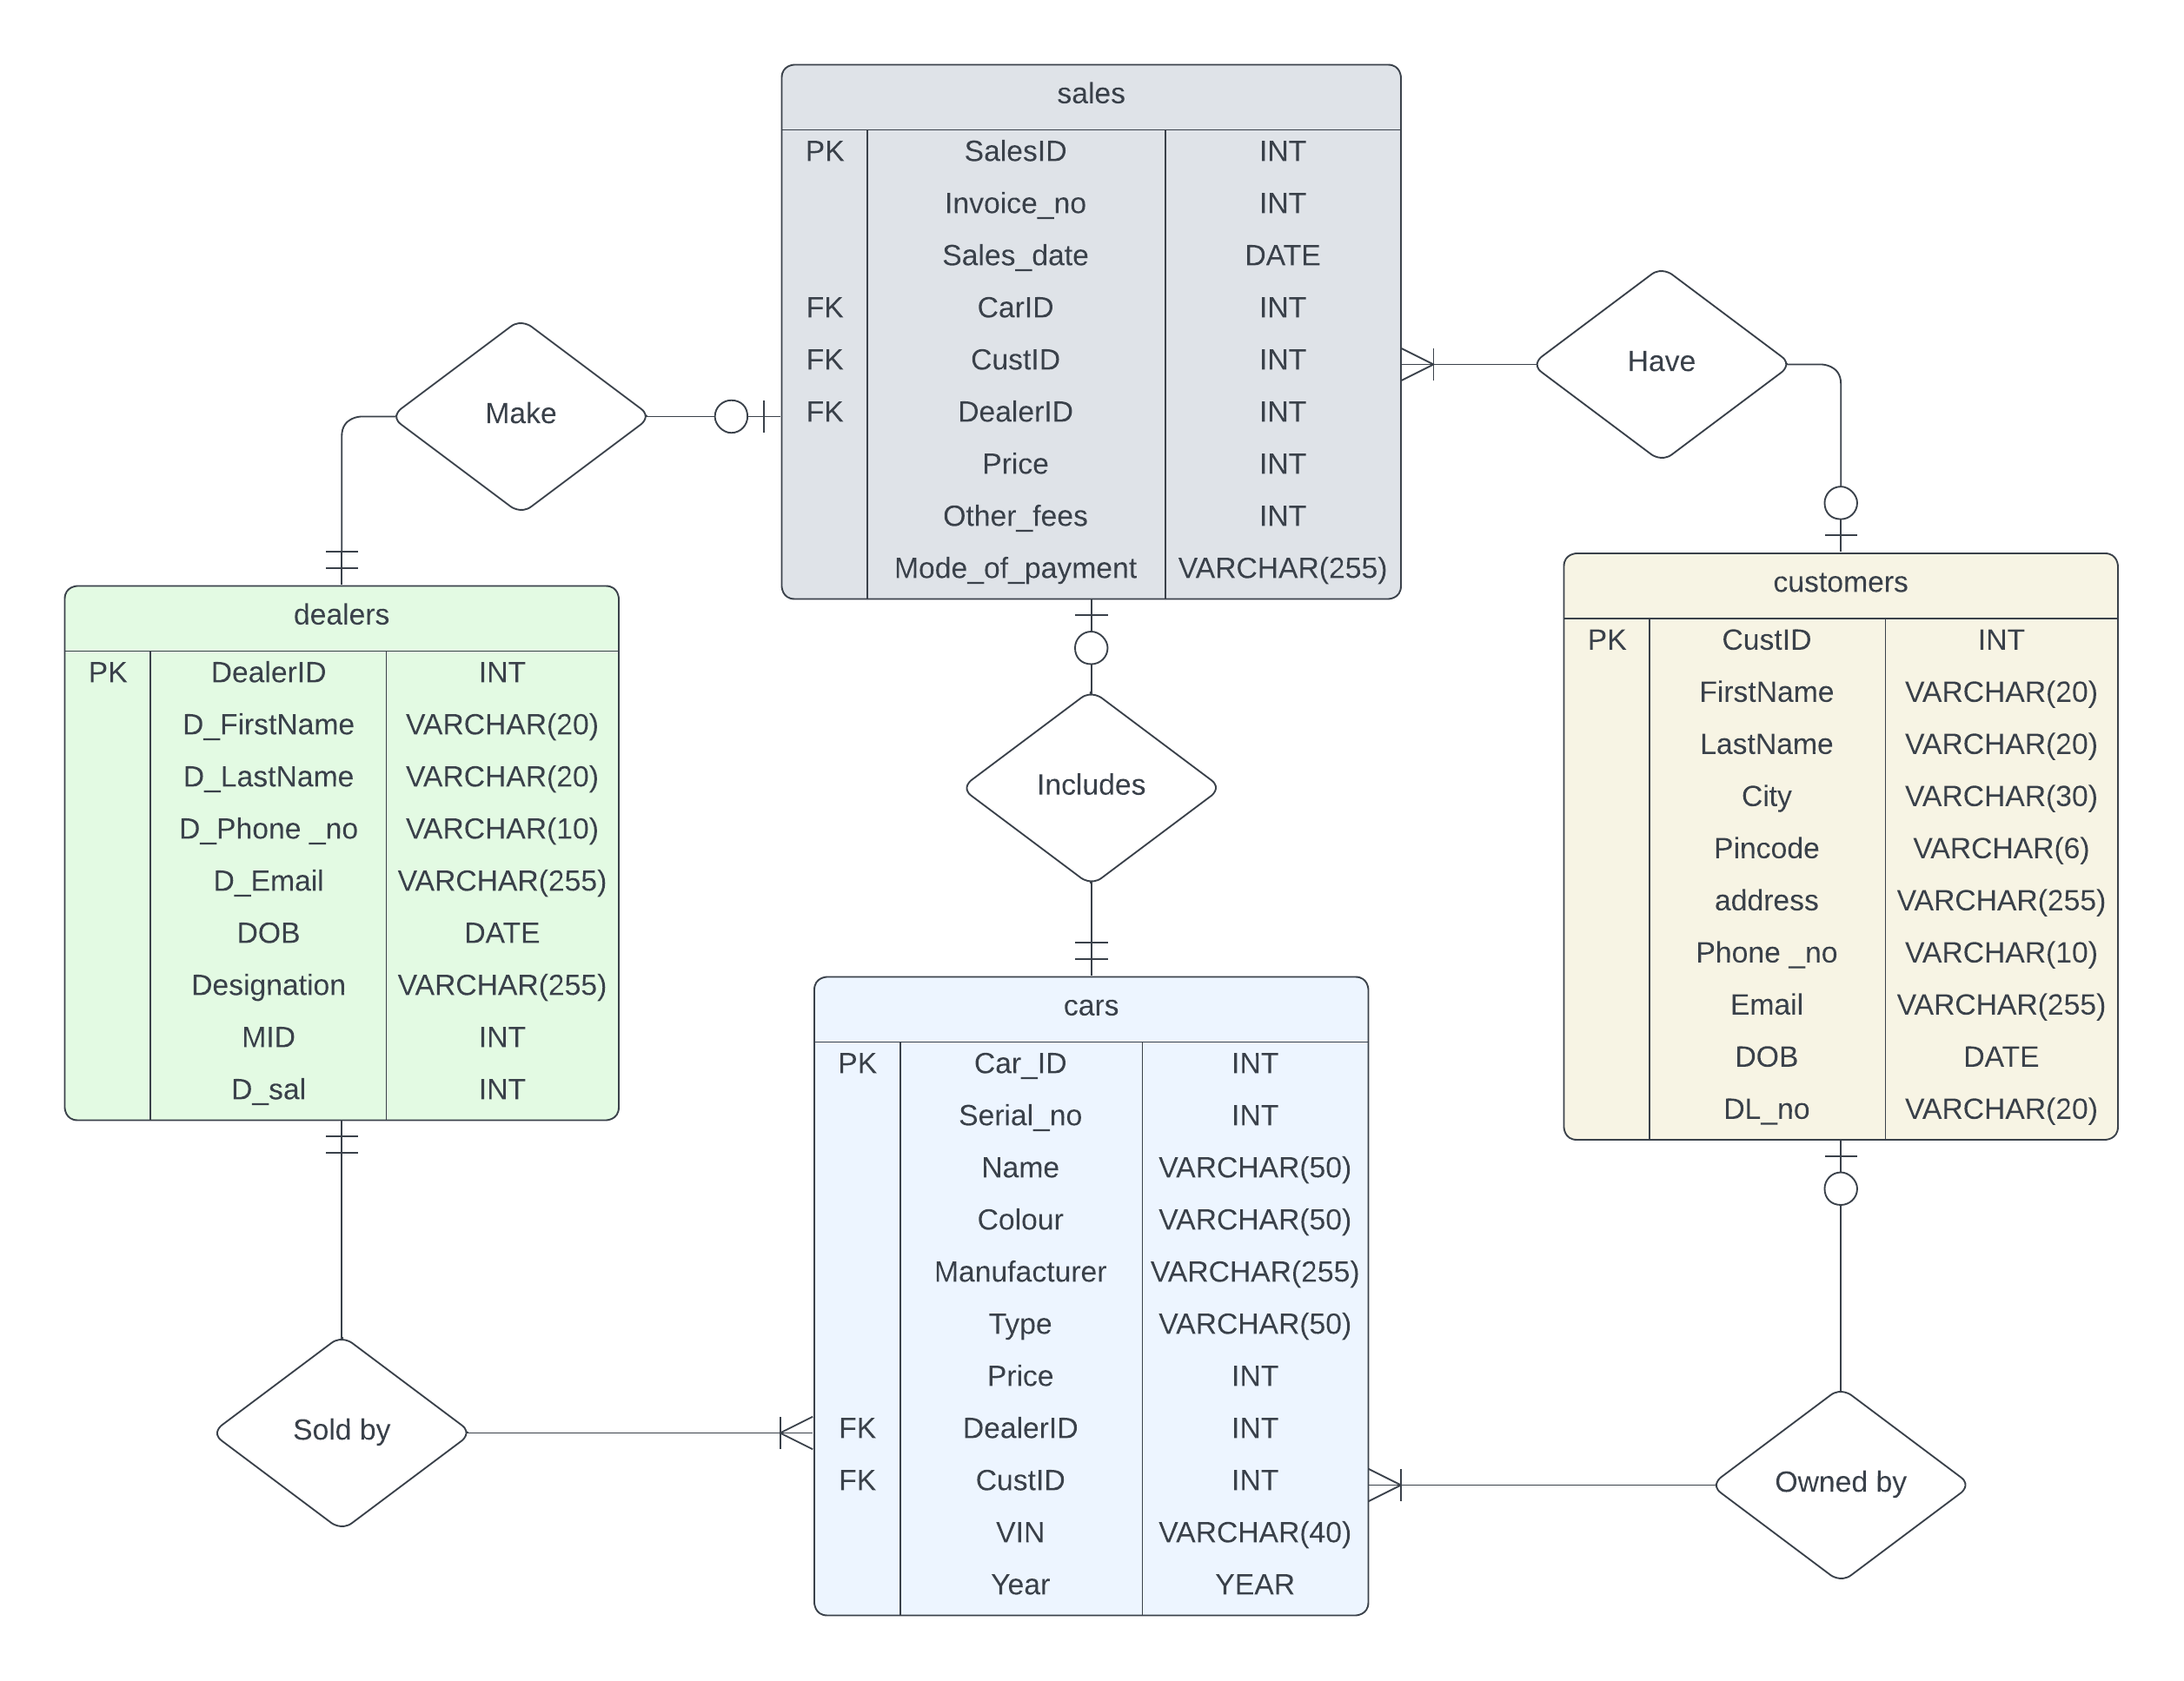

**STRUCTURE OF TABLE’S**

* CUSTOMERS

* DEALERS

* SALES

* CARS

**CONTENT OF TABLE’S**

* CUSTOMERS

* DEALERS

* SALES

* CARS

**OPERATOR’S**

* **ARITHMETIC**

**Query:**

**Query:**

**Query:**

**Query:**

* **COMPARISON**

**Query:**

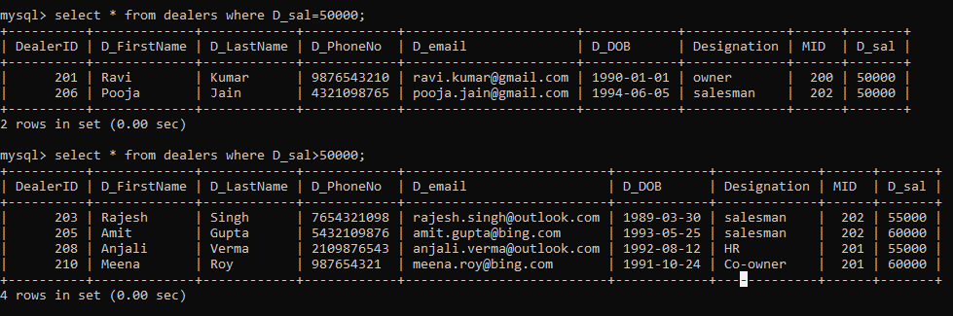

* **LOGICAL**

**Query:**

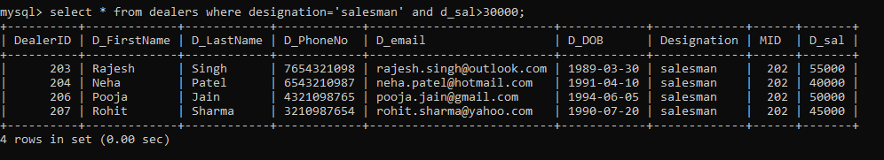

**Query:**

* **RANGE, LIKE, LI**ST

**Query:**

**Query:**

**Query:**

**Query:**

**Query:**

**Query:**

**Query:**

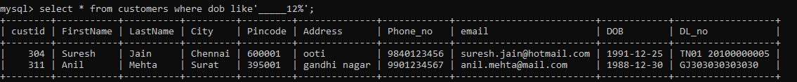

**Query:**

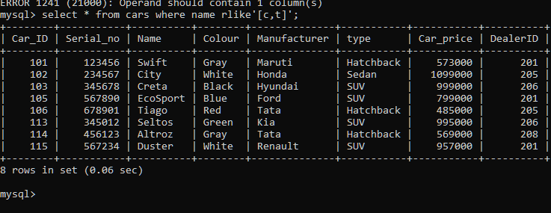

**AGGREGATE FUNCTION’S**

* MIN

**Query:**

* MAX

**Query:**

* SUM

**Query:**

* AVG

**Query:**

* COUNT

**Query:**

**CLAUSE’S**

* **WHERE CLAUSE**

**Query:**

* **GROUP BY CLAUSE**

**Query:**

* **HAVING CLAUSE**

**Query:**

* **ORDER BY CLAUSE**

**Query:**

**Query:**

* **LIMIT CLAUSE**

**Query:**

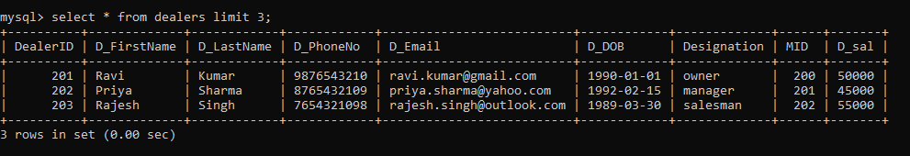

**JOIN’S**

1. **INNER JOIN**

**Query:**

1. **LEFT JOIN**

**Query:**

1. **RIGHT JOIN**

**Query:**

1. **SELF JOIN**

**Query:**

1. **CROSS JOIN**

**Query:**

**SUB-QUERIES**

**Query:**

**Query:**

**Query:**

**Query:**

**OTHER FUNCTION’S AND STATMENT’S**

**Query:**

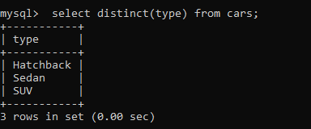

**Query:**

**Query:**

